Faculty of Engineering, Architecture and Science
Department of Mechanical, Industrial, and Mechatronics Engineering
Program | Electrical Engineering
Course Number | MEC511
Course Title | Thermodynamics and Fluids
Semester/Year | W2026
Instructor | Dr. Jun Cao

Lab/Tutorial Report NO. | Lab Report #3

Report Title | Lab Report #3: Temperature Pressure Relationship

Section No. | 09
Submission Date | March 9, 2026
Due Date | March 9, 2026

Name | Student ID | Signature*
Shai Mourad | 501170415
Chaz Dyer | 501304851
Amolika Brahmbhatt | 501295080
Joshua Cardoz | 501025493
Glenn Bangtuan | 501327493

*By signing above you attest that you have contributed to this submission and confirm that all
work you have contributed to this submission is your own work. Any suspicion of copying or
plagiarism in this work will result in an investigation of Academic Misconduct and may result
in a “0” on the work, an “F” in the course, or possibly more severe penalties, as well as a
Disciplinary Notice on your academic record under the Student Code of Academic Conduct,
which can be found online at:
https://www.torontomu.ca/senate/policies/pol60.pdf.

Table of Contents

ii. Summary 2
1. Introduction 3
2. Apparatus 3
3. Procedure 3
4. Results & Calculations 4
4.1 Ratio for the absolute pressure 5
4.2 Theoretical Temperature and Percent Error 5
5. Discussion 7
6. Conclusion 8
7. References 9
8. Appendix 10

ii. Summary
This laboratory experiment documented the relationship between the temperature and pressure for saturated steam in an enclosed steam boiler that underwent a constant volume process. The boiler, which was heated to boiling temperature, and then subsequent measurements were recorded in small intervals of 0.5 bar, starting from 0.5 bar to 15 bar. The results of the experiment showed that temperature increased proportionally with pressure, consistent with the corresponding values in the steam tables. Although there were minor discrepancies among the subsequent pressure values, the first value had the maximum percent error of 20.09% and an average percent error of 4.15%. The experimental data were very close to the theoretical thermodynamic values. The deviations can be attributed to heat loss to the lab environment and instrument inaccuracy during the experiment.

1. Introduction
The relationship between pressure and temperature is an important concept in thermodynamics, especially when studying the behaviour of saturated steam. When water is heated in a closed system, the temperature and pressure inside the system increase together. For saturated steam in equilibrium with liquid water, each pressure corresponds to a specific saturation temperature. These values are well established and are commonly listed in saturated steam tables used in thermodynamic analysis. In this experiment, the relationship between pressure and temperature for saturated steam is examined using the WL 204 enclosed model steam boiler. Water inside a sealed vessel is heated using an electric heater until it reaches boiling conditions and produces steam. As the pressure inside the boiler increases, the corresponding temperature is measured using a temperature sensor while the pressure is indicated by a mechanical manometer. The objective of this experiment is to observe how the temperature of saturated steam changes as pressure increases and to compare the experimental measurements with theoretical values obtained from saturated steam tables. By analysing the pressure and temperature data and calculating the corresponding theoretical temperatures, the experiment demonstrates the expected thermodynamic relationship between pressure and temperature for saturated steam.

2. Apparatus
- WL 204 enclosed model steam boiler

3. Procedure
- Measure the barometric pressure and correct for local conditions such as temperature and ambient pressure
- Switch on the unit at the master switch (9).
- Switch on the heater using the heater switch and heat up the boiler. The heater control is limited to a temperature of 200°C to prevent excess pressure build-up
- Deaerate the boiler by heating it to 100 °C. Allow the water to cook for approximately 1 minute so that the steam passes through the open valve (3).
- Log the boiler pressure and temperature values in increments of approximately 0.5 bar.
- Compare the measurements with the values from the literature.
- After completing the experiment, switch off the unit at the master switch, disconnect the unit from the mains power, and allow the boiler to cool down.

4. Results & Calculations
Table 1. Experimental Pressure and Temperature Measurements for Saturated Steam
Relative Pressure (Bar) | Abs. Pressure (Bar)  = 1.013 bar (or p_{atm}) + p_{rel} | Temperature (˚C)
0.5 | 1.513 | 89.2
1 | 2.013 | 103.7
1.5 | 2.513 | 114.1
2 | 3.013 | 122.9
2.5 | 3.513 | 129.5
3 | 4.013 | 134.3
4 | 5.013 | 143.2
5 | 6.013 | 157.8
6 | 7.013 | 164.4
7 | 8.013 | 170.1
8 | 9.013 | 174.9
9 | 10.013 | 179.4
10 | 11.013 | 183.5
11 | 12.013 | 187.4
12 | 13.013 | 191.1
13 | 14.013 | 194.5
14 | 15.013 | 197.7
15 | 16.013 | 200.3

4.1 Ratio for the absolute pressure
From Table A3 (See Appendix):
(p₁, T₁) = (1.50 bar, 111.4°C)
(p₂, T₂) = (2.00 bar, 120.2°C)

$Ratio=r = \frac{p_{abs} - p_{1}}{p_{2} -p_{1}}$ Eq. 1
$r= \frac{1.513 bar - 1.50 bar}{2.00 bar - 1.50 bar} = 0.026$

4.2 Theoretical Temperature and Percent Error
T* = (1 − r) × T₁ + r × T₂ Eq. 2

Percent Error (%) = 100 × (T − T*) / T* Eq. 3

Table 2. Theoretical Temperature and Percent Error Calculations
Relative Pressure (Bar) | Abs. Pressure (Bar) | Temperature (˚C) | Theoretical Temperature (˚C) | Percent Error (%)
0.5 | 1.513 | 89.2 | 111.63 | 20.09
1 | 2.013 | 103.7 | 120.39 | 13.86
1.5 | 2.513 | 114.1 | 127.56 | 10.55
2 | 3.013 | 122.9 | 133.74 | 8.10
2.5 | 3.513 | 129.5 | 139.02 | 6.85
3 | 4.013 | 134.3 | 143.71 | 6.55
4 | 5.013 | 143.2 | 151.99 | 5.78
5 | 6.013 | 157.8 | 158.98 | 0.74
6 | 7.013 | 164.4 | 165.07 | 0.41
7 | 8.013 | 170.1 | 170.47 | 0.21
8 | 9.013 | 174.9 | 175.46 | 0.32
9 | 10.013 | 179.4 | 179.95 | 0.30
10 | 11.013 | 183.5 | 183.63 | 0.07
11 | 12.013 | 187.4 | 187.31 | 0.05
12 | 13.013 | 191.1 | 190.99 | 0.06
13 | 14.013 | 194.5 | 194.67 | 0.09
14 | 15.013 | 197.7 | 198.34 | 0.32
15 | 16.013 | 200.3 | 201.16 | 0.43

$Average \%error=\frac{Σ\%error}{18}$ Eq. 4

$Average \%error=\frac{(74.78)}{18}≈4.15\%$

From Table 2 and the calculation using Eq. 4, the maximum and the average percentage error between the results and published steam table values are 20.09% and 4.15% respectively.
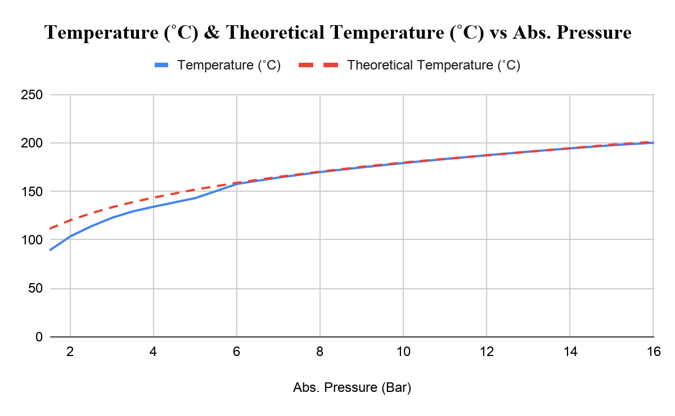
Figure 1. Temperature (˚C) and Theoretical Temperature (˚C) versus Absolute Pressure (Bar) Plot

5. Discussion
This lab investigates the proportional relationship between pressure and temperature in regards to saturated steam at constant volume. The boiler was heated, and the measured temperature and pressure were recorded and later compared with values obtained from the saturated steam tables.
From the experimental data, an increasing relationship between pressure and temperature was recorded. From 0.5 to 15 bar in pressure, the measured temperature increased from approximately 89.2°C to 200.3°C. This trend is very consistent with theoretical concepts of saturated steam, where higher pressures correspond to higher saturation temperatures. Plotted results show similar trends to the steam tables, showing that the experiment follows the expected thermodynamic relationship. It was also calculated that the maximum and the average percentage error between the results and published steam table values are 20.09% and 4.15% respectively.
Very small deviations are observed when comparing theoretical to actual values. These changes are due to various experimental factors, such as instrumentation accuracy. Particularly the pressure gauge and temperature sensor used in the apparatus. Small calibration errors in these instruments can introduce discrepancies in recorded values.
The lab room is not an ideal environment, leading to heat loss from the boiler to the surrounding environment. Even with insulation, the boiler and the surroundings likely had some level of heat transfer. Furthermore, dynamic conditions inside the boiler are also a contributing factor to value differences. Perfect thermodynamic equilibrium may not have occurred for each reading.
Overall even with minor discrepancy, the theoretical results match the experimental values and follow the theoretical saturation curve reasonably well. This means there was a successful demonstration of the relationship between pressure and temperature for saturated steam and confirmed the expected thermodynamic behavior.

6. Conclusion
This lab examines the relationship between pressure and temperature for saturated steam in a closed boiler system. From 0.5 to 15 bar, experimental results (temperature, pressure) were recorded and calculated.
From the observed results, temperature increases with increasing pressure. This is consistent with the theoretical saturated steam pressure–temperature relationship found in the steam tables. After plotting the results, the resulting data was very similar to the theoretical data.
Despite very small differences between the actual and predicted results, these changes can be explained by measurement uncertainty, heat losses, and possible non-equilibrium conditions during data collection.
To conclude, this lab experiment successfully demonstrated the thermodynamic pressure/temperature relationship in a saturated steam system while confirming that increasing pressure results in an increase in saturation temperature.

7. References

[1] R. S. Budny, MEC511 Laboratory Manual: Steam Pressure/Temperature Relationship (Lab 3), Dept. of Mechanical and Industrial Engineering, Faculty of Engineering, Architecture and Science, Ryerson University, Jan. 2016.
[2] R. D. Blevins, Applied Fluid Dynamics Handbook, New York, NY, USA: Van Nostrand Reinhold, 1984.

8. Appendix
Table A-3. Properties of Saturated Water (Liquid-Vapor): Pressure Table [1]
